**DATA BASE**

**MANAGEMENT SYSTEM**

***SALARY MANAGEMENT SYSTEM***

Project Review 3

LAB SLOT: L5+L6

Submitted To: - Prof. Nagaraju M

Group Members:

SHUBHAM GUPTA – 17BCE0199

PUSHPAM PATEL – 17BCE0291

PATEL YASH VIJAYKUMAR – 17BCE0335

INTRODUCTION

Salary Management System is the heart of any Human Resource System of an organization. The solution has to take care of the calculation of salary as per rules of the company, income tax calculation and various deductions to be done from the salary including statutory deductions like Income tax and provident fund deductions. It has to generate pay-slip, cheque summary and MIS reports.

It is understood that we are tired of managing thousands of odd papers, pay slips, payroll reports, and salary details and so on. Imagine that we have a payroll processing system which will generate our pay slips and payroll reports within seconds. We can help others automated your payroll system by developing a customized payroll application that suits your specific requirements.

**PURPOSE**

Main aim of developing Employee Payroll Management is to provide an easy way not only to automate all functionalities involved managing leaves and Payroll for the employees of Company, but also to provide full functional reports to management of Company with the details about usage of leave facility and Salaries paid or to be paid to employees.

We are committed to bring the best way of management in the various forms of EPM. We understand that EPM in not just a product to be sold, it is a tool to manage the inner operation of Company related to employee leave and Payroll.

**SCOPE**

This Application works in Multiple PC’s installed on multiple Computers by sharing same database by which users of different department can use it sitting at different locations simultaneously.

Further, it can be easily customized for the use of any other type of firm. This project will help them to create a working system into the latest concept of *paperless office.*

**Existing System**

Presently salary calculation is done manually, it takes so much of time to compose salary of all employees. It also takes very long time to make salary slip ready. Due to manual process some time it takes very long time, in turn it delays the salary distribution. This is a big problem to manage when salary is not generated in time. Even with double cross check here or there some errors will happen, this again create large problem. To solve all this the organization, require very good software to take care of all these.

**Proposed System**

The proposed software will solve all the problems they are facing now. This software is designed such way that it will generate the salary every month in time. So there not much worries. This software also equipped with to enter the allowance and deductions of each employee in the organization, it help them to track each employee net salary, based on this we can generate the salary slip . The software built to generate individual pay slip and summary of the payroll

**Objective**

The main objective of the project is to *computerize the processing of Salary Calculation and Management.*

This package is useful in maintaining *Employee and Attendance details for Salary Processing.*

**Problem Definition**

The project “Salary Management System” shows a simple Salary Management procedure conducted in small organizations.

The system should be developed to maintain the employee record and their attendance details.

Customer needs must be taken into account.

A proper database should be maintained in the RDMS and the front end to be developed using advanced GUI interfaces.

The system should be able to handle exceptional situations.

**Problem Identification**

The organization is using a manual system to calculate salaries and tax of employees. They also have to calculate and keep record of tax of whole organization and maintain tax files manually.

The management of organization also has to deal with bank files manually. All this work requires a lot of paper work, is extremely time-consuming job, and accordingly costly as well, as they have to hire more man power.

Since there is always a risk of human errors present in a manual system so the chances of errors are very high and to figure out such errors is also a very lengthy procedure. Therefore, the organization decided to switch from a manual system to an automated computerized salary management system.

The requirement of the organization is to develop a web-based application that is able to deal with salary and tax calculation of employees within the organization and maintain its data base.

Furthermore, this system should be able to generate automatic files such as, salary slips, bank files and tax files in response of queries from the data stored in the database

Details of Hardware & Software used

**Platform**: Windows 10

**Tools**: Java NetBeans7.2

**RDBMS**: SQLite

Hardware Specifications

**Microprocessor (CPU)**: Dual Core

**Memory (RAM)**: 4 GB

**Virtual Memory**: 32-bit

**Hard Disk**: 500 GB

**VDU**: SVGA

**Keyboard**: Standard 104 Keys

**Mouse**: Standard 3-buttons Mouse (Scroll)

**Printer**: Inkjet / Laser

Software Specifications

**Operating System**: Windows 7

**Front-End Design** : Java NetBeans 7.2

**Back-End**: SQLite

**Documentation** : Microsoft Word 2010 and MS Paint

TABLE

Allowance

|  |  |  |
| --- | --- | --- |
| **DATA NAME** | **DATA TYPE** | **SIZE** |
| Id | INTEGER PRIMARY KEY NOT NULL | 5 |
| Overtime | VARCHAR | 4 |
| Medical | VARCHAR | 4 |
| Bonus | VARCHAR | 6 |
| Emp_id | INTEGER | 5 |
| Salary | VARCHAR_DEFAULT (null) | 6 |
| Rate | VARCHAR_DEFAULT (null) | 2 |
| total_allowance | VARCHAR | 6 |
| First_name | VARCHAR | 10 |
| Surname | VARCHAR | 10 |
| Created By | VARCHAR | 10 |

Audit

|  |  |  |
| --- | --- | --- |
| **DATA NAME** | **DATA TYPE** | **SIZE** |
| Audit_Id | INTEGER PRIMARY KEY NOT NULL | 5 |
| Emp_id | INTEGER | 5 |
| date | DATE |  |
| Status | VARCHAR | 10 |

Deduction

|  |  |  |
| --- | --- | --- |
| **DATA NAME** | **DATA TYPE** | **SIZE** |
| Id | INTEGER PRIMARY KEY NOT NULL | 5 |
| First_name | VARCHAR | 10 |
| Surname | VARCHAR | 10 |
| Emp_id | INTEGER | 5 |
| deduction_amount | INTEGER | 5 |
| deduction_reason | VARCHAR | 10 |
| Made_by | VARCHAR | 10 |

STAFF INFORMATION

|  |  |  |
| --- | --- | --- |
| **DATA NAME** | **DATA TYPE** | **SIZE** |
| Id | INTEGER PRIMARY KEY NOT NULL | 5 |
| First_name | VARCHAR | 10 |
| Surname | VARCHAR | 10 |
| Email | VARCHAR | 20 |
| Tel | INTEGER | 10 |
| ADD | VARCHAR | 25 |
| Dept | VARCHAR | 10 |
| Gender | CHAR | 2 |
| Salary | VARCHAR_DEFAULT (null) | 6 |
| ADD2 | VARCHAR | 25 |
| Apartment | VARCHAR | 25 |
| Pcode | INTEGER | 10 |
| Designation | VARCHAR | 10 |
| Status | VARCHAR | 10 |
| Date_Hire | DATE |  |
| Job_title | Varchar | 10 |

USER

|  |  |  |
| --- | --- | --- |
| **DATA NAME** | **DATA TYPE** | **SIZE** |
| Id | INTEGER PRIMARY KEY NOT NULL | 5 |
| Division | VARCHAR | 10 |
| USERNAME | VARCHAR | 10 |
| PASSWORD | VARCHAR | 10 |
| Emp_id | INTEGER | 5 |

SQLITE_SEQUENCE

|  |  |  |
| --- | --- | --- |
| **DATA NAME** | **DATA TYPE** | **SIZE** |
| NAME | VARCHAR | 15 |
| Seq | VARCHAR | 10 |

Sample Code –

“MAIN MENU SEGMENT”

package employee.payroll.system;

import com.itextpdf.text.BaseColor;

import com.itextpdf.text.pdf.PdfWriter;

import java.awt.Dimension;

import java.awt.Toolkit;

import com.itextpdf.text.Document;

import com.itextpdf.text.DocumentException;

import com.itextpdf.text.Element;

import com.itextpdf.text.Font.FontFamily;

import com.itextpdf.text.FontFactory;

import com.itextpdf.text.Paragraph;

import com.itextpdf.text.Phrase;

import com.itextpdf.text.pdf.GrayColor;

import com.itextpdf.text.pdf.PdfPCell;

import com.itextpdf.text.pdf.PdfWriter;

import com.itextpdf.text.pdf.PdfPTable;

import java.awt.Font;

import java.io.File;

import java.io.FileNotFoundException;

import java.io.FileOutputStream;

import java.io.OutputStream;

import java.sql.Connection;

import java.sql.PreparedStatement;

import java.sql.ResultSet;

import java.sql.ResultSetMetaData;

import java.text.DateFormat;

import java.text.SimpleDateFormat;

import java.util.logging.Level;

import java.util.logging.Logger;

import javax.swing.JFileChooser;

import javax.swing.JOptionPane;

import java.util.Date;

import java.util.GregorianCalendar;

public class MainMenu extends javax.swing.JFrame {

Connection conn=null;

ResultSet rs=null;

PreparedStatement pst=null;

public MainMenu() {

initComponents();

conn=db.java_db();

Toolkit toolkit = getToolkit();

Dimension size = toolkit.getScreenSize();

setLocation(size.width/2 - getWidth()/2,

size.height/2 - getHeight()/2);

txt_emp.setText(String.valueOf(Emp.empId).toString());

}

@SuppressWarnings("unchecked")

// <editor-fold defaultstate="collapsed" desc="Generated Code">

private void initComponents() {

jMenuBar2 = new javax.swing.JMenuBar();

jMenu3 = new javax.swing.JMenu();

jMenu4 = new javax.swing.JMenu();

jPanel2 = new javax.swing.JPanel();

jButton6 = new javax.swing.JButton();

jButton7 = new javax.swing.JButton();

jButton3 = new javax.swing.JButton();

jButton2 = new javax.swing.JButton();

add_employee = new javax.swing.JButton();

jButton4 = new javax.swing.JButton();

jButton5 = new javax.swing.JButton();

jLabel1 = new javax.swing.JLabel();

txt_emp = new javax.swing.JLabel();

jLabel2 = new javax.swing.JLabel();

jTextField1 = new javax.swing.JTextField();

jMenuBar1 = new javax.swing.JMenuBar();

jMenu1 = new javax.swing.JMenu();

jMenuItem1 = new javax.swing.JMenuItem();

jMenu5 = new javax.swing.JMenu();

jMenuItem6 = new javax.swing.JMenuItem();

jMenuItem7 = new javax.swing.JMenuItem();

jMenuItem2 = new javax.swing.JMenuItem();

btn_menu = new javax.swing.JMenu();

jMenuItem13 = new javax.swing.JMenuItem();

jMenuItem5 = new javax.swing.JMenuItem();

jMenu7 = new javax.swing.JMenu();

jMenuItem3 = new javax.swing.JMenuItem();

jMenu3.setText("File");

jMenuBar2.add(jMenu3);

jMenu4.setText("Edit");

jMenuBar2.add(jMenu4);

setDefaultCloseOperation(javax.swing.WindowConstants.DISPOSE_ON_CLOSE);

setResizable(false);

jPanel2.setLayout(null);

jButton6.setBackground(new java.awt.Color(255, 255, 255));

jButton6.setIcon(new javax.swing.ImageIcon(getClass().getResource("/employee/payroll/system/Images/logout.png"))); // NOI18N

jButton6.addActionListener(new java.awt.event.ActionListener() {

public void actionPerformed(java.awt.event.ActionEvent evt) {

jButton6ActionPerformed(evt);

}

});

jPanel2.add(jButton6);

jButton6.setBounds(950, 10, 40, 30);

jButton7.setFont(new java.awt.Font("Arial", 1, 11)); // NOI18N

jButton7.setIcon(new javax.swing.ImageIcon(getClass().getResource("/employee/payroll/system/Images/Payment.png"))); // NOI18N

jButton7.setText("Payment");

jButton7.addActionListener(new java.awt.event.ActionListener() {

public void actionPerformed(java.awt.event.ActionEvent evt) {

jButton7ActionPerformed(evt);

}

});

jPanel2.add(jButton7);

jButton7.setBounds(780, 520, 197, 59);

jButton3.setFont(new java.awt.Font("Arial", 1, 11)); // NOI18N

jButton3.setIcon(new javax.swing.ImageIcon(getClass().getResource("/employee/payroll/system/Images/Deduction.png"))); // NOI18N

jButton3.setText("Deduction");

jButton3.addActionListener(new java.awt.event.ActionListener() {

public void actionPerformed(java.awt.event.ActionEvent evt) {

jButton3ActionPerformed(evt);

}

});

jPanel2.add(jButton3);

jButton3.setBounds(560, 520, 197, 59);

jButton2.setFont(new java.awt.Font("Arial", 1, 11)); // NOI18N

jButton2.setIcon(new javax.swing.ImageIcon(getClass().getResource("/employee/payroll/system/Images/Allowance.png"))); // NOI18N

jButton2.setText("Allowance");

jButton2.addActionListener(new java.awt.event.ActionListener() {

public void actionPerformed(java.awt.event.ActionEvent evt) {

jButton2ActionPerformed(evt);

}

});

jPanel2.add(jButton2);

jButton2.setBounds(560, 450, 197, 59);

add_employee.setFont(new java.awt.Font("Arial", 1, 11)); // NOI18N

add_employee.setIcon(new javax.swing.ImageIcon(getClass().getResource("/employee/payroll/system/Images/Add_Employee.png"))); // NOI18N

add_employee.setText("Employee Manager");

add_employee.addActionListener(new java.awt.event.ActionListener() {

public void actionPerformed(java.awt.event.ActionEvent evt) {

add_employeeActionPerformed(evt);

}

});

jPanel2.add(add_employee);

add_employee.setBounds(560, 380, 197, 59);

jButton4.setFont(new java.awt.Font("Arial", 1, 11)); // NOI18N

jButton4.setIcon(new javax.swing.ImageIcon(getClass().getResource("/employee/payroll/system/Images/Search.png"))); // NOI18N

jButton4.setText("Search");

jButton4.addActionListener(new java.awt.event.ActionListener() {

public void actionPerformed(java.awt.event.ActionEvent evt) {

jButton4ActionPerformed(evt);

}

});

jPanel2.add(jButton4);

jButton4.setBounds(780, 380, 197, 59);

jButton5.setFont(new java.awt.Font("Arial", 1, 11)); // NOI18N

jButton5.setIcon(new javax.swing.ImageIcon(getClass().getResource("/employee/payroll/system/Images/Update.png"))); // NOI18N

jButton5.setText("Update Salary");

jButton5.addActionListener(new java.awt.event.ActionListener() {

public void actionPerformed(java.awt.event.ActionEvent evt) {

jButton5ActionPerformed(evt);

}

});

jPanel2.add(jButton5);

jButton5.setBounds(780, 450, 197, 59);

jLabel1.setForeground(new java.awt.Color(255, 255, 255));

jLabel1.setText("Logged in As :");

jPanel2.add(jLabel1);

jLabel1.setBounds(10, 590, 90, 14);

txt_emp.setForeground(new java.awt.Color(255, 255, 255));

txt_emp.setText("Employee ID");

jPanel2.add(txt_emp);

txt_emp.setBounds(90, 590, 80, 14);

jLabel2.setIcon(new javax.swing.ImageIcon(getClass().getResource("/employee/payroll/system/Images/bk2.jpg"))); // NOI18N

jPanel2.add(jLabel2);

jLabel2.setBounds(0, 0, 1000, 620);

jTextField1.setText("jTextField1");

jMenu1.setText("Employee");

jMenuItem1.setText("Employee Registeration");

jMenuItem1.addActionListener(new java.awt.event.ActionListener() {

public void actionPerformed(java.awt.event.ActionEvent evt) {

jMenuItem1ActionPerformed(evt);

}

});

jMenu1.add(jMenuItem1);

jMenuBar1.add(jMenu1);

jMenu5.setText("Reports");

jMenuItem6.setText("Employees RP");

jMenuItem6.addActionListener(new java.awt.event.ActionListener() {

public void actionPerformed(java.awt.event.ActionEvent evt) {

jMenuItem6ActionPerformed(evt);

}

});

jMenu5.add(jMenuItem6);

jMenuItem7.setText("Employee Total Allowance RP");

jMenuItem7.addActionListener(new java.awt.event.ActionListener() {

public void actionPerformed(java.awt.event.ActionEvent evt) {

jMenuItem7ActionPerformed(evt);

}

});

jMenu5.add(jMenuItem7);

jMenuItem2.setText("Employee Total Deduction RP");

jMenuItem2.addActionListener(new java.awt.event.ActionListener() {

public void actionPerformed(java.awt.event.ActionEvent evt) {

jMenuItem2ActionPerformed(evt);

}

});

jMenu5.add(jMenuItem2);

jMenuBar1.add(jMenu5);

btn_menu.setText("Audit");

jMenuItem13.setText("Add User");

jMenuItem13.addActionListener(new java.awt.event.ActionListener() {

public void actionPerformed(java.awt.event.ActionEvent evt) {

jMenuItem13ActionPerformed(evt);

}

});

btn_menu.add(jMenuItem13);

jMenuItem5.setText("Audit Trail");

jMenuItem5.addActionListener(new java.awt.event.ActionListener() {

public void actionPerformed(java.awt.event.ActionEvent evt) {

jMenuItem5ActionPerformed(evt);

}

});

btn_menu.add(jMenuItem5);

jMenuBar1.add(btn_menu);

jMenu7.setText("About");

jMenuItem3.setText("Version 1.0");

jMenu7.add(jMenuItem3);

jMenuBar1.add(jMenu7);

setJMenuBar(jMenuBar1);

javax.swing.GroupLayout layout = new javax.swing.GroupLayout(getContentPane());

getContentPane().setLayout(layout);

layout.setHorizontalGroup(

layout.createParallelGroup(javax.swing.GroupLayout.Alignment.LEADING)

.addComponent(jPanel2, javax.swing.GroupLayout.DEFAULT_SIZE, 996, Short.MAX_VALUE)

);

layout.setVerticalGroup(

layout.createParallelGroup(javax.swing.GroupLayout.Alignment.LEADING)

.addComponent(jPanel2, javax.swing.GroupLayout.DEFAULT_SIZE, 616, Short.MAX_VALUE)

);

pack();

}// </editor-fold>

private void jMenuItem13ActionPerformed(java.awt.event.ActionEvent evt) {

// TODO add your handling code here:

users x = new users();

x.setVisible(true);

}

private void jMenuItem5ActionPerformed(java.awt.event.ActionEvent evt) {

// TODO add your handling code here:

Audit_details x = new Audit_details();

x.setVisible(true);

}

private void jButton5ActionPerformed(java.awt.event.ActionEvent evt) {

// TODO add your handling code here:

updateSalary x = new updateSalary();

x.setVisible(true);

}

private void jButton4ActionPerformed(java.awt.event.ActionEvent evt) {

// TODO add your handling code here:

searchEmployee e = new searchEmployee();

e.setVisible(true);

}

private void add_employeeActionPerformed(java.awt.event.ActionEvent evt) {

// TODO add your handling code here:

addEmployee x = new addEmployee();

x.setVisible(true);

}

private void jButton2ActionPerformed(java.awt.event.ActionEvent evt) {

// TODO add your handling code here:

Allowance x = new Allowance();

x.setVisible(true);

}

private void jButton6ActionPerformed(java.awt.event.ActionEvent evt) {

// TODO add your handling code here:

login x = new login();

x.setVisible(true);

this.dispose();

try{

Date currentDate = GregorianCalendar.getInstance().getTime();

DateFormat df = DateFormat.getDateInstance();

String dateString = df.format(currentDate);

Date d = new Date();

SimpleDateFormat sdf = new SimpleDateFormat("HH:mm:ss");

String timeString = sdf.format(d);

String value0 = timeString;

String values = dateString;

int value = Emp.empId;

String reg = "insert into Audit (emp_id,date,status) values ('"+value+"','"+value0+" / "+values+"','Logged out')";

pst=conn.prepareStatement(reg);

pst.execute();

this.dispose();

}catch (Exception e){

JOptionPane.showMessageDialog(null, e);

}

finally {

try{

rs.close();

pst.close();

}

catch(Exception e){

}

}

}

private void jMenuItem1ActionPerformed(java.awt.event.ActionEvent evt) {

// TODO add your handling code here:

addEmployee x = new addEmployee();

x.setVisible(true);

}

private void jMenuItem6ActionPerformed(java.awt.event.ActionEvent evt) {

JFileChooser dialog = new JFileChooser();

dialog.setSelectedFile(new File("Employees Report.pdf"));

int dialogResult = dialog.showSaveDialog(null);

if (dialogResult==JFileChooser.APPROVE_OPTION){

String filePath = dialog.getSelectedFile().getPath();

try {

// TODO add your handling code here:

String sql ="select * from Staff_information";

pst=conn.prepareStatement(sql);

rs=pst.executeQuery();

Document myDocument = new Document();

PdfWriter myWriter = PdfWriter.getInstance(myDocument, new FileOutputStream(filePath ));

PdfPTable table = new PdfPTable(13);

myDocument.open();

float[] columnWidths = new float[] {3,8,7,5,5,9,8,9,6,6,6,8,8};

table.setWidths(columnWidths);

table.setWidthPercentage(100); //set table width to 100%

myDocument.add(new Paragraph("Employees List",FontFactory.getFont(FontFactory.TIMES_BOLD,20,Font.BOLD )));

myDocument.add(new Paragraph(new Date().toString()));

myDocument.add(new Paragraph("-------------------------------------------------------------------------------------------"));

table.addCell(new PdfPCell(new Paragraph("ID",FontFactory.getFont(FontFactory.TIMES_ROMAN,9,Font.BOLD))));

table.addCell(new PdfPCell(new Paragraph("First Name",FontFactory.getFont(FontFactory.TIMES_ROMAN,9,Font.BOLD))));

table.addCell(new PdfPCell(new Paragraph("Surname",FontFactory.getFont(FontFactory.TIMES_ROMAN,9,Font.BOLD))));

table.addCell(new PdfPCell(new Paragraph("Date of Birth",FontFactory.getFont(FontFactory.TIMES_ROMAN,9,Font.BOLD))));

table.addCell(new PdfPCell(new Paragraph("Email",FontFactory.getFont(FontFactory.TIMES_ROMAN,9,Font.BOLD))));

table.addCell(new PdfPCell(new Paragraph("Telephone",FontFactory.getFont(FontFactory.TIMES_ROMAN,9,Font.BOLD))));

table.addCell(new PdfPCell(new Paragraph("Address",FontFactory.getFont(FontFactory.TIMES_ROMAN,9,Font.BOLD))));

table.addCell(new PdfPCell(new Paragraph("Department",FontFactory.getFont(FontFactory.TIMES_ROMAN,9,Font.BOLD))));

table.addCell(new PdfPCell(new Paragraph("Gender",FontFactory.getFont(FontFactory.TIMES_ROMAN,9,Font.BOLD))));

table.addCell(new PdfPCell(new Paragraph("Salary",FontFactory.getFont(FontFactory.TIMES_ROMAN,9,Font.BOLD))));

table.addCell(new PdfPCell(new Paragraph("Status",FontFactory.getFont(FontFactory.TIMES_ROMAN,9,Font.BOLD))));

table.addCell(new PdfPCell(new Paragraph("Date Hired",FontFactory.getFont(FontFactory.TIMES_ROMAN,9,Font.BOLD))));

table.addCell(new PdfPCell(new Paragraph("Job Title",FontFactory.getFont(FontFactory.TIMES_ROMAN,9,Font.BOLD))));

while(rs.next())

{

table.addCell(new PdfPCell(new Paragraph(rs.getString(1),FontFactory.getFont(FontFactory.TIMES_ROMAN,8,Font.PLAIN))));

table.addCell(new PdfPCell(new Paragraph(rs.getString(2),FontFactory.getFont(FontFactory.TIMES_ROMAN,8,Font.PLAIN))));

table.addCell(new PdfPCell(new Paragraph(rs.getString(3),FontFactory.getFont(FontFactory.TIMES_ROMAN,8,Font.PLAIN))));

table.addCell(new PdfPCell(new Paragraph(rs.getString(4),FontFactory.getFont(FontFactory.TIMES_ROMAN,8,Font.PLAIN))));

table.addCell(new PdfPCell(new Paragraph(rs.getString(5),FontFactory.getFont(FontFactory.TIMES_ROMAN,8,Font.PLAIN))));

table.addCell(new PdfPCell(new Paragraph(rs.getString(6),FontFactory.getFont(FontFactory.TIMES_ROMAN,8,Font.PLAIN))));

table.addCell(new PdfPCell(new Paragraph(rs.getString(7),FontFactory.getFont(FontFactory.TIMES_ROMAN,8,Font.PLAIN))));

table.addCell(new PdfPCell(new Paragraph(rs.getString(8),FontFactory.getFont(FontFactory.TIMES_ROMAN,8,Font.PLAIN))));

table.addCell(new PdfPCell(new Paragraph(rs.getString(10),FontFactory.getFont(FontFactory.TIMES_ROMAN,8,Font.PLAIN))));

table.addCell(new PdfPCell(new Paragraph(rs.getString(11),FontFactory.getFont(FontFactory.TIMES_ROMAN,8,Font.PLAIN))));

table.addCell(new PdfPCell(new Paragraph(rs.getString(16),FontFactory.getFont(FontFactory.TIMES_ROMAN,8,Font.PLAIN))));

table.addCell(new PdfPCell(new Paragraph(rs.getString(17),FontFactory.getFont(FontFactory.TIMES_ROMAN,8,Font.PLAIN))));

table.addCell(new PdfPCell(new Paragraph(rs.getString(18),FontFactory.getFont(FontFactory.TIMES_ROMAN,8,Font.PLAIN))));

}

myDocument.add(table);

myDocument.add(new Paragraph("--------------------------------------------------------------------------------------------"));

myDocument.close();

JOptionPane.showMessageDialog(null,"Report was successfully generated");

}

catch(Exception e){

JOptionPane.showMessageDialog(null,e);

}

finally {

try{

rs.close();

pst.close();

}

catch(Exception e){

JOptionPane.showMessageDialog(null,e);

}

}

}

}

private void jMenuItem7ActionPerformed(java.awt.event.ActionEvent evt) {

// TODO add your handling code here:

JFileChooser dialog = new JFileChooser();

dialog.setSelectedFile(new File("Employee Allowance Report.pdf"));

int dialogResult = dialog.showSaveDialog(null);

if (dialogResult==JFileChooser.APPROVE_OPTION){

String filePath = dialog.getSelectedFile().getPath();

try {

// TODO add your handling code here:

String sql ="select * from Allowance";

pst=conn.prepareStatement(sql);

rs=pst.executeQuery();

Document myDocument = new Document();

PdfWriter myWriter = PdfWriter.getInstance(myDocument, new FileOutputStream(filePath ));

PdfPTable table = new PdfPTable(11);

myDocument.open();

float[] columnWidths = new float[] { 3,7,7,5,5,9,6,5,8,8,8};

table.setWidths(columnWidths);

table.setWidthPercentage(100); //set table width to 100%

myDocument.add(new Paragraph("Employees Allowance List",FontFactory.getFont(FontFactory.TIMES_BOLD,20,Font.BOLD )));

myDocument.add(new Paragraph(new Date().toString()));

myDocument.add(new Paragraph("-------------------------------------------------------------------------------------------"));

table.addCell(new PdfPCell(new Paragraph("ID",FontFactory.getFont(FontFactory.TIMES_ROMAN,10,Font.BOLD))));

table.addCell(new PdfPCell(new Paragraph("Overtime",FontFactory.getFont(FontFactory.TIMES_ROMAN,10,Font.BOLD))));

table.addCell(new PdfPCell(new Paragraph("Medical",FontFactory.getFont(FontFactory.TIMES_ROMAN,10,Font.BOLD))));

table.addCell(new PdfPCell(new Paragraph("Bonus",FontFactory.getFont(FontFactory.TIMES_ROMAN,10,Font.BOLD))));

table.addCell(new PdfPCell(new Paragraph("Other",FontFactory.getFont(FontFactory.TIMES_ROMAN,10,Font.BOLD))));

table.addCell(new PdfPCell(new Paragraph("Employee ID",FontFactory.getFont(FontFactory.TIMES_ROMAN,10,Font.BOLD))));

table.addCell(new PdfPCell(new Paragraph("Salary",FontFactory.getFont(FontFactory.TIMES_ROMAN,10,Font.BOLD))));

table.addCell(new PdfPCell(new Paragraph("Rate",FontFactory.getFont(FontFactory.TIMES_ROMAN,10,Font.BOLD))));

table.addCell(new PdfPCell(new Paragraph("Allowance",FontFactory.getFont(FontFactory.TIMES_ROMAN,10,Font.BOLD))));

table.addCell(new PdfPCell(new Paragraph("First Name",FontFactory.getFont(FontFactory.TIMES_ROMAN,10,Font.BOLD))));

table.addCell(new PdfPCell(new Paragraph("Surname",FontFactory.getFont(FontFactory.TIMES_ROMAN,10,Font.BOLD))));

while(rs.next())

{

table.addCell(new PdfPCell(new Paragraph(rs.getString(1),FontFactory.getFont(FontFactory.TIMES_ROMAN,9,Font.PLAIN))));

table.addCell(new PdfPCell(new Paragraph(rs.getString(2),FontFactory.getFont(FontFactory.TIMES_ROMAN,9,Font.PLAIN))));

table.addCell(new PdfPCell(new Paragraph(rs.getString(3),FontFactory.getFont(FontFactory.TIMES_ROMAN,9,Font.PLAIN))));

table.addCell(new PdfPCell(new Paragraph(rs.getString(4),FontFactory.getFont(FontFactory.TIMES_ROMAN,9,Font.PLAIN))));

table.addCell(new PdfPCell(new Paragraph(rs.getString(5),FontFactory.getFont(FontFactory.TIMES_ROMAN,9,Font.PLAIN))));

table.addCell(new PdfPCell(new Paragraph(rs.getString(6),FontFactory.getFont(FontFactory.TIMES_ROMAN,9,Font.PLAIN))));

table.addCell(new PdfPCell(new Paragraph(rs.getString(7),FontFactory.getFont(FontFactory.TIMES_ROMAN,9,Font.PLAIN))));

table.addCell(new PdfPCell(new Paragraph(rs.getString(8),FontFactory.getFont(FontFactory.TIMES_ROMAN,9,Font.PLAIN))));

table.addCell(new PdfPCell(new Paragraph(rs.getString(9),FontFactory.getFont(FontFactory.TIMES_ROMAN,9,Font.PLAIN))));

table.addCell(new PdfPCell(new Paragraph(rs.getString(10),FontFactory.getFont(FontFactory.TIMES_ROMAN,9,Font.PLAIN))));

table.addCell(new PdfPCell(new Paragraph(rs.getString(11),FontFactory.getFont(FontFactory.TIMES_ROMAN,9,Font.PLAIN))));

}

myDocument.add(table);

myDocument.add(new Paragraph("--------------------------------------------------------------------------------------------"));

myDocument.close();

JOptionPane.showMessageDialog(null,"Report was successfully generated");

}

catch(Exception e){

JOptionPane.showMessageDialog(null,e);

}

finally {

try{

rs.close();

pst.close();

}

catch(Exception e){

JOptionPane.showMessageDialog(null,e);

}

}

}

}

private void jButton3ActionPerformed(java.awt.event.ActionEvent evt) {

// TODO add your handling code here:

employeeDeductions x = new employeeDeductions();

x.setVisible(true);

}

private void jButton7ActionPerformed(java.awt.event.ActionEvent evt) {

// TODO add your handling code here:

searchEmpSalarySlip x = new searchEmpSalarySlip();

x.setVisible(true);

}

private void jMenuItem2ActionPerformed(java.awt.event.ActionEvent evt) {

// TODO add your handling code here:

JFileChooser dialog = new JFileChooser();

dialog.setSelectedFile(new File("Employee Deduction Report.pdf"));

int dialogResult = dialog.showSaveDialog(null);

if (dialogResult==JFileChooser.APPROVE_OPTION){

String filePath = dialog.getSelectedFile().getPath();

try {

// TODO add your handling code here:

String sql ="select * from Deductions";

pst=conn.prepareStatement(sql);

rs=pst.executeQuery();

Document myDocument = new Document();

PdfWriter myWriter = PdfWriter.getInstance(myDocument, new FileOutputStream(filePath ));

PdfPTable table = new PdfPTable(8);

myDocument.open();

float[] columnWidths = new float[] { 3,7,7,5,5,9,6,5};

table.setWidths(columnWidths);

table.setWidthPercentage(100); //set table width to 100%

myDocument.add(new Paragraph("Employees Deduction List",FontFactory.getFont(FontFactory.TIMES_BOLD,20,Font.BOLD )));

myDocument.add(new Paragraph(new Date().toString()));

myDocument.add(new Paragraph("-------------------------------------------------------------------------------------------"));

table.addCell(new PdfPCell(new Paragraph("ID",FontFactory.getFont(FontFactory.TIMES_ROMAN,10,Font.BOLD))));

table.addCell(new PdfPCell(new Paragraph("First Name",FontFactory.getFont(FontFactory.TIMES_ROMAN,10,Font.BOLD))));

table.addCell(new PdfPCell(new Paragraph("Surname",FontFactory.getFont(FontFactory.TIMES_ROMAN,10,Font.BOLD))));

table.addCell(new PdfPCell(new Paragraph("Salary",FontFactory.getFont(FontFactory.TIMES_ROMAN,10,Font.BOLD))));

table.addCell(new PdfPCell(new Paragraph("Deduction Amount",FontFactory.getFont(FontFactory.TIMES_ROMAN,10,Font.BOLD))));

table.addCell(new PdfPCell(new Paragraph("Deduction Reason",FontFactory.getFont(FontFactory.TIMES_ROMAN,10,Font.BOLD))));

table.addCell(new PdfPCell(new Paragraph("Employee ID",FontFactory.getFont(FontFactory.TIMES_ROMAN,10,Font.BOLD))));

table.addCell(new PdfPCell(new Paragraph("Created By",FontFactory.getFont(FontFactory.TIMES_ROMAN,10,Font.BOLD))));

while(rs.next())

{

table.addCell(new PdfPCell(new Paragraph(rs.getString(1),FontFactory.getFont(FontFactory.TIMES_ROMAN,9,Font.PLAIN))));

table.addCell(new PdfPCell(new Paragraph(rs.getString(2),FontFactory.getFont(FontFactory.TIMES_ROMAN,9,Font.PLAIN))));

table.addCell(new PdfPCell(new Paragraph(rs.getString(3),FontFactory.getFont(FontFactory.TIMES_ROMAN,9,Font.PLAIN))));

table.addCell(new PdfPCell(new Paragraph(rs.getString(4),FontFactory.getFont(FontFactory.TIMES_ROMAN,9,Font.PLAIN))));

table.addCell(new PdfPCell(new Paragraph(rs.getString(5),FontFactory.getFont(FontFactory.TIMES_ROMAN,9,Font.PLAIN))));

table.addCell(new PdfPCell(new Paragraph(rs.getString(6),FontFactory.getFont(FontFactory.TIMES_ROMAN,9,Font.PLAIN))));

table.addCell(new PdfPCell(new Paragraph(rs.getString(7),FontFactory.getFont(FontFactory.TIMES_ROMAN,9,Font.PLAIN))));

table.addCell(new PdfPCell(new Paragraph(rs.getString(8),FontFactory.getFont(FontFactory.TIMES_ROMAN,9,Font.PLAIN))));

}

myDocument.add(table);

myDocument.add(new Paragraph("--------------------------------------------------------------------------------------------"));

myDocument.close();

JOptionPane.showMessageDialog(null,"Report was successfully generated");

}

catch(Exception e){

JOptionPane.showMessageDialog(null,e);

}

finally {

try{

rs.close();

pst.close();

}

catch(Exception e){

JOptionPane.showMessageDialog(null,e);

}

}

}

}

/**

* @param args the command line arguments

*/

public static void main(String args[]) {

/* Set the Nimbus look and feel */

//<editor-fold defaultstate="collapsed" desc=" Look and feel setting code (optional) ">

/* If Nimbus (introduced in Java SE 6) is not available, stay with the default look and feel.

* For details see http://download.oracle.com/javase/tutorial/uiswing/lookandfeel/plaf.html

*/

try {

for (javax.swing.UIManager.LookAndFeelInfo info : javax.swing.UIManager.getInstalledLookAndFeels()) {

if ("Nimbus".equals(info.getName())) {

javax.swing.UIManager.setLookAndFeel(info.getClassName());

break;

}

}

} catch (ClassNotFoundException ex) {

java.util.logging.Logger.getLogger(MainMenu.class.getName()).log(java.util.logging.Level.SEVERE, null, ex);

} catch (InstantiationException ex) {

java.util.logging.Logger.getLogger(MainMenu.class.getName()).log(java.util.logging.Level.SEVERE, null, ex);

} catch (IllegalAccessException ex) {

java.util.logging.Logger.getLogger(MainMenu.class.getName()).log(java.util.logging.Level.SEVERE, null, ex);

} catch (javax.swing.UnsupportedLookAndFeelException ex) {

java.util.logging.Logger.getLogger(MainMenu.class.getName()).log(java.util.logging.Level.SEVERE, null, ex);

}

//</editor-fold>

//</editor-fold>

/* Create and display the form */

java.awt.EventQueue.invokeLater(new Runnable() {

public void run() {

new MainMenu().setVisible(true);

}

});

}

// Variables declaration - do not modify

private javax.swing.JButton add_employee;

private javax.swing.JMenu btn_menu;

private javax.swing.JButton jButton2;

private javax.swing.JButton jButton3;

private javax.swing.JButton jButton4;

private javax.swing.JButton jButton5;

private javax.swing.JButton jButton6;

private javax.swing.JButton jButton7;

private javax.swing.JLabel jLabel1;

private javax.swing.JLabel jLabel2;

private javax.swing.JMenu jMenu1;

private javax.swing.JMenu jMenu3;

private javax.swing.JMenu jMenu4;

private javax.swing.JMenu jMenu5;

private javax.swing.JMenu jMenu7;

private javax.swing.JMenuBar jMenuBar1;

private javax.swing.JMenuBar jMenuBar2;

private javax.swing.JMenuItem jMenuItem1;

private javax.swing.JMenuItem jMenuItem13;

private javax.swing.JMenuItem jMenuItem2;

private javax.swing.JMenuItem jMenuItem3;

private javax.swing.JMenuItem jMenuItem5;

private javax.swing.JMenuItem jMenuItem6;

private javax.swing.JMenuItem jMenuItem7;

private javax.swing.JPanel jPanel2;

private javax.swing.JTextField jTextField1;

private javax.swing.JLabel txt_emp;

// End of variables declaration

}

Screenshots –

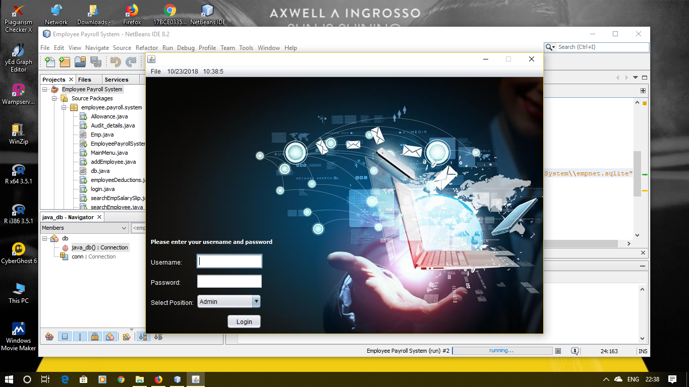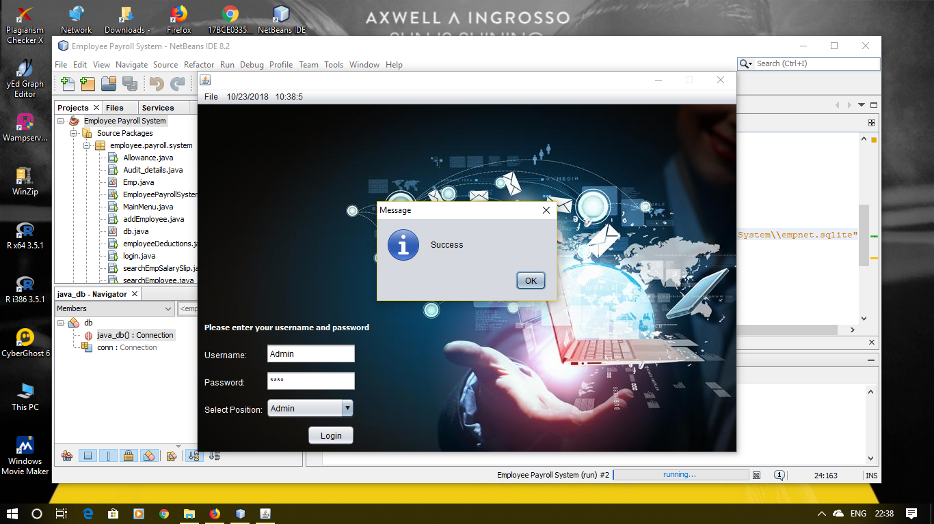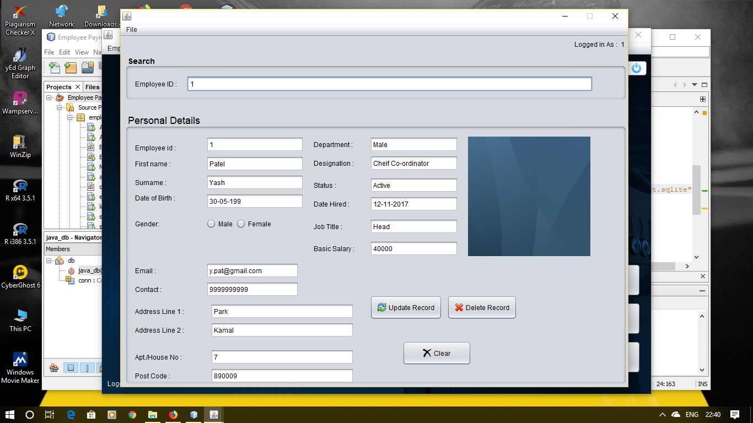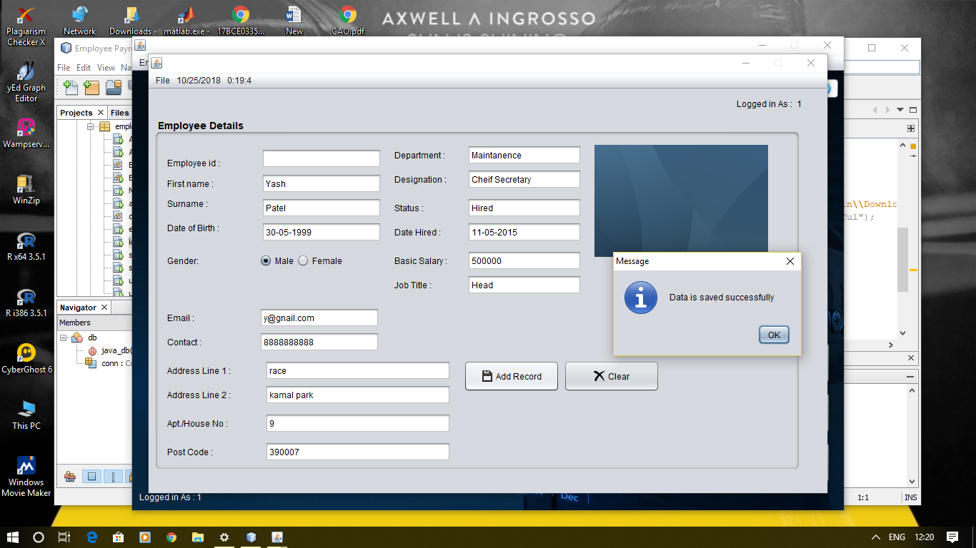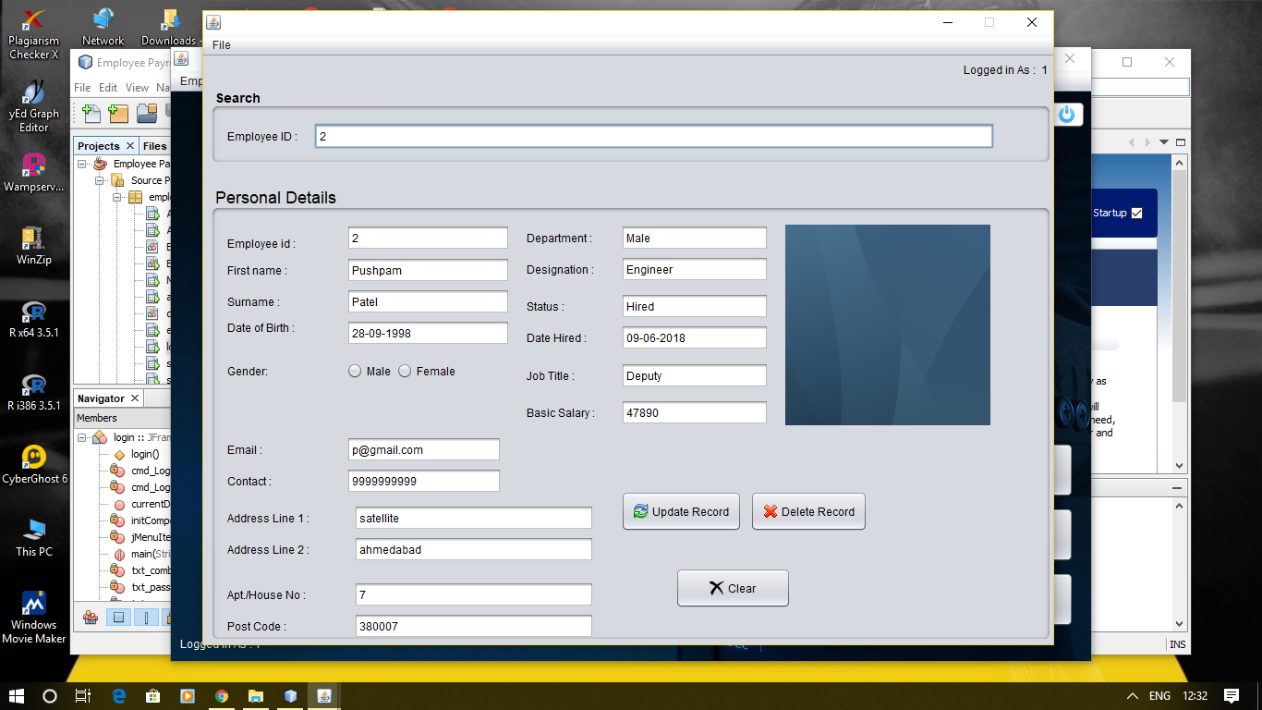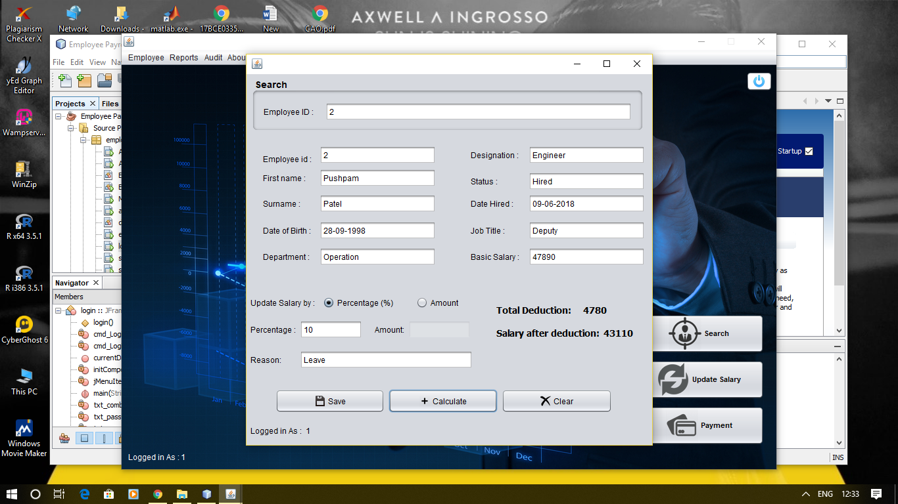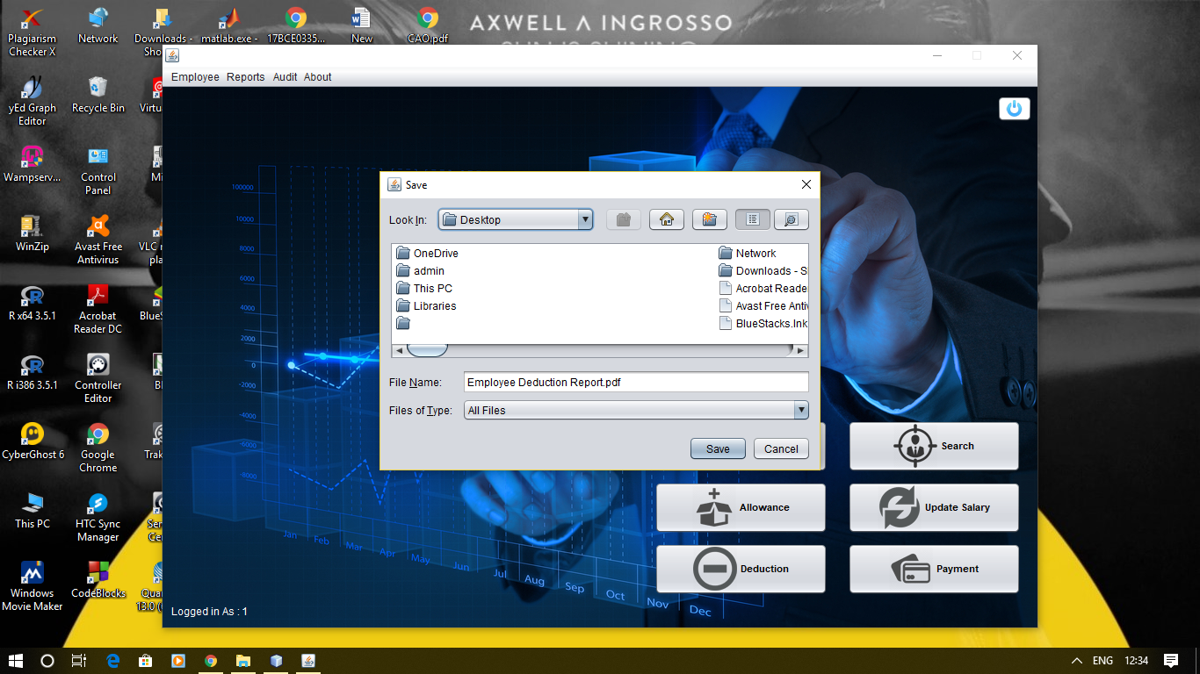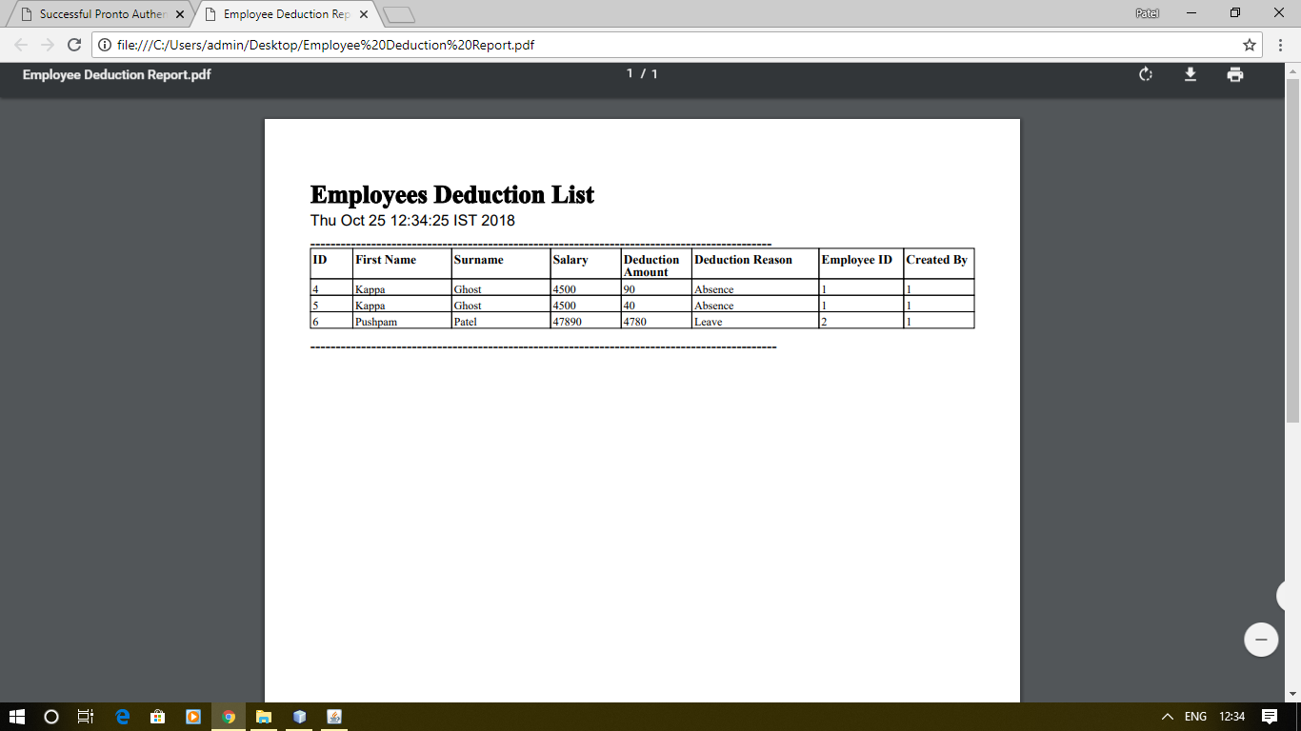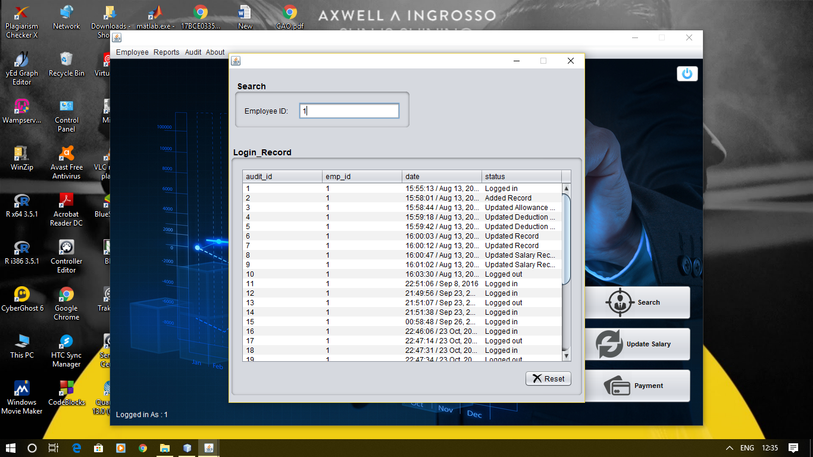

**THANK YOU**